Instructions to run Course mall Application

• Synch Empowher-Curriculum repository with origin from GitHub 1

• Checkout latest code in your personal system by running command git pull origin main 1

• Import the project into IntelliJ IDEA 1

• Maven Build the application 2

• Run the Spring Boot application 2

• After application is up run application GET Url in browser: 3

# Synch Empowher-Curriculum repository with origin from GitHub

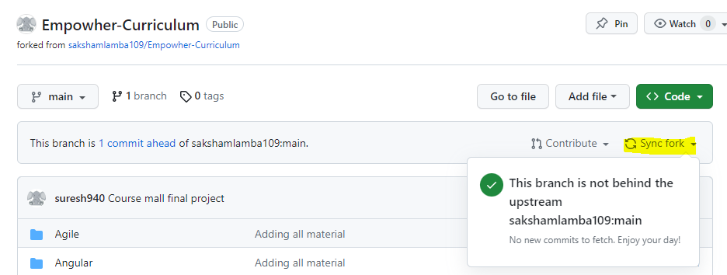

# Checkout latest code in your personal system by running command git pull origin main

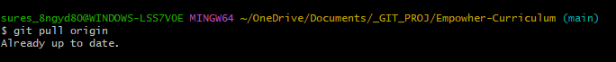

Note: If you face any errors, you can checkout new copy of Empowher-Curriculum

# Import the project into IntelliJ IDEA

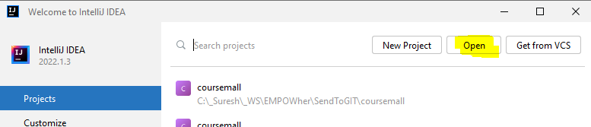

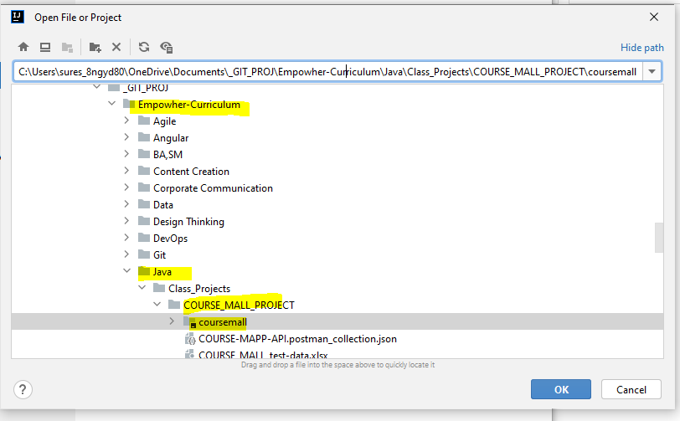

Open IntelliJ IDEA and click on Open. Navigate to the coursemall project folder and select it. IntelliJ IDEA will automatically detect your project and import it.

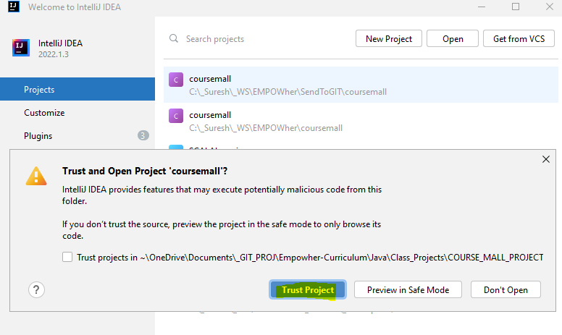

# Maven Build the application

Open a terminal window in IntelliJ IDEA and navigate to your project directory. Run mvn clean install command to build your application.

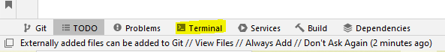

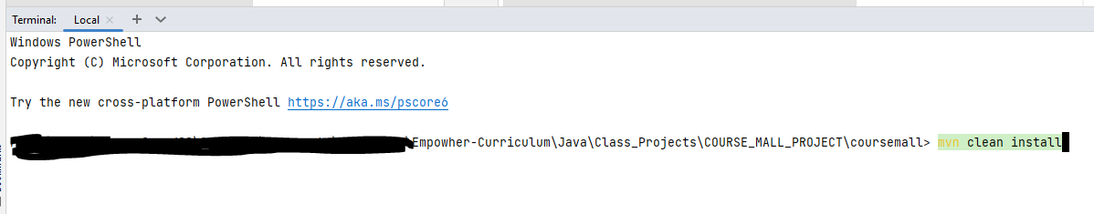

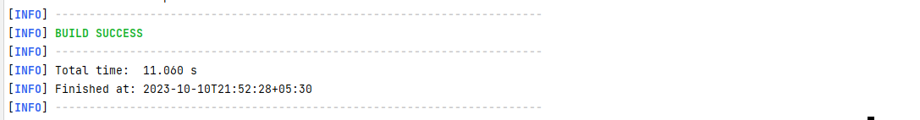

*Build should success as above*

# Run the Spring Boot application

To run your Spring Boot application, open the *coursemall/src/main/java/com/empowher/coursemall/CourseMallApplication.java* file and click on the green arrow next to the main method. Alternatively, you can right-click on the *CourseMallApplication.java* file and select Run *CourseMallApplication*.main().

IDE Short cut: Ctrl+shift+F10

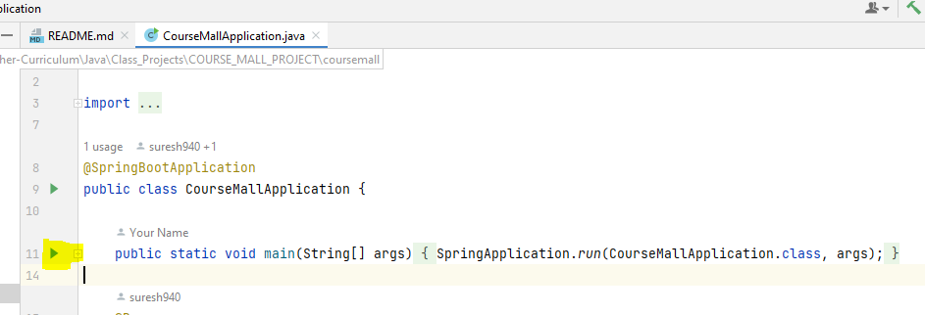

Wait for a few seconds for the application to start up.

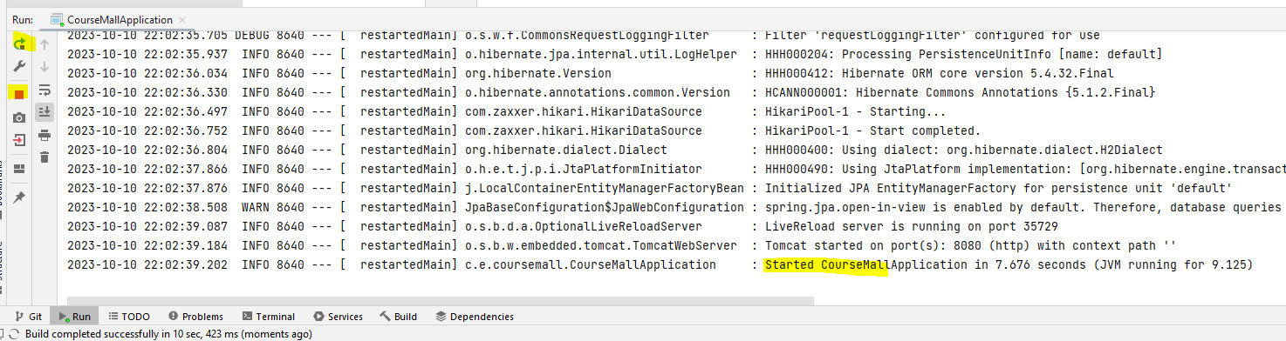

# After application is up run application GET URL in browser:

Once it has started, open a web browser and enter http://localhost:8080/courses in the address bar. This will open up your Spring Boot application in your web browser.

